

**Tribhuvan University**

**Institute of Science and Technology**

**Himalaya College of Engineering**

**[Code: CSC-404]**

A

Final Year Project Defense Report

on

“Fruit Recognition System using CNN”

by

**Kushal Poudel [10869/073]**

**Mahesh Pandey [10871/073]**

**Samrat Ghimire [10883/073]**

**Upendra Acharya [10894/073]**

Submitted to Department of Computer Science and Information Technology in partial fulfillment of the requirement for the Bachelor’s degree in Computer Science and Information Technology

**Department of Computer Science and Information Technology**

March 17, 2020

Contents

Chapter 1 Introduction 1

1.1 Introduction 1

1.2 Problem Definition 2

1.3 Objective 3

1.4 Scope and Limitations 3

1.5 Report Organization 4

Chapter 2 Literature Reviews 5

Chapter 3 Requirement Analysis and Feasibility study 6

3.1 Requirement Analysis 6

3.1.1 Functional Requirement 6

3.2 Feasibility Study 7

3.2.1 Schedule 7

3.3 Structuring System Requirement 8

3.3.1 System Flowchart 8

3.3.2 Class Diagram 10

Chapter 4: System Design 11

4.1 Architectural Design 11

4.2 Activity Diagram 12

4.3 Sequence Diagram 13

4.3.1 Admin sequence diagram 13

4.3.2 User Sequence Diagram 14

4.4 Algorithm 15

Chapter 5 Expected Output 15

List of Figures

|  |  |  |
| --- | --- | --- |
| Fig no. | Name of figure | Page no. |
| 1 | Use case Diagram for Books Recommendation System | 6 |
| 2 | Gantt chart for Books Recommendation System | 7 |
| 3 | Flow chart for Book Recommendation System | 8 |
| 4 | Class Diagram for Book Recommendation System | 9 |
| 5 | System Architecture for Book Recommendation System | 11 |
| 6 | Activity Diagram for Book Recommendation System | 12 |
| 7 | Admin Sequence Diagram for Book Recommendation System | 13 |
| 8 | User Sequence Diagram for Book Recommendation System | 14 |

# Chapter 1 Introduction

## 1.1 Introduction

With the lively improvement of our human society, additional attention has been paid to the superiority of our life, particularly the food we eat. Over the last few years, computer visions have been widely used in fruit recognition methods. In the field of image recognition and classification, Deep Neural Network (DNN) is used to identify fruits from images. DNN performs better than other machine learning algorithms. Convolutional Neural Networks (CNNs) are classified as a deep learning algorithm. In deep learning, CNN are the most commonly used type of Artificial Neural Networks (ANNs). It is being used several visual recognition analyzing which includes video and image recognition, face recognition, handwritten digit recognition, and fruit recognition etc. The accuracies in these fields including fruit recognition using CNN have reached human-level perfection

CNN has a very similar architecture as ANN. There are several neurons in each layer in ANN. Hence, the weighted sum of all the neurons of a layer becomes the input of a neuron of the next layer adding a biased value. In CNN the layer has three dimensions. Here all the neurons are not fully connected instead they are connected to the local receptive field. A cost function is generated in order to train the network. It compares the network’s output with the desired output. Accurate and efficient fruit recognition is of great importance in the field of robotic harvesting and yield mapping. An ideal fruit recognition system is accurate that can be trained on an easily available dataset, shows real-time predictions and acclimates various types of fruits. Therefore, in our research, we implement a fruit recognition classifier using CNN. The input image is taken as 100×100 pixels of RGB image. For the networks best performance, we used various combinations of hidden layers for five cases and observe the accuracies. The final experiment result shows the much-improved fruit recognition rate. The mathematical model of the network is executed in python with tensorflow.

## 1.2 Problem Definition

As the advancement in Internet Technology began couple of decades back, millions of the goods and products are sold and bought online. Online commerce (e-commerce) has become the backbone of global transaction these days. Back in the days the ecommerce is the fancy way of buying and selling the goods and products, but the quality of the product was always questionable since the other users who has bought the same items don’t have the appropriate means of the sharing the information of the product with the world. Then ratings and review system came along that changed the way users and customers look and buy things over the internet. But still while people are buying and selling products over the internet they are still unaware variety of the products that has been sold or bought unless they do some market research and investigate their inventory.

Recommendation system gives relief on that sector of the e-commerce for both users as well as the merchants. So, the main motive of this project is to design the system that takes the reviews (comments) of the product in this case books that has been sold and read over the internet and give the appropriate recommendation to the user about the similar books that they might like and interested in looking to their past choices of the books they have made. The reviews that users have given for the book are taken and using the Collaborative Filtering Recommendation algorithm the appropriate recommendation is made.

## 1.3 Objective

The objective of developing this project is to take the book reviews from the users and analyze them using collaborative filtering method to recommend the appropriate book for the users from the large community of the users. The concrete objectives of the project are given as follows:

• To create book rating data base where users can rate a book and give reviews.

• To develop recommendation system that suggests user possible interesting books from the database based on the reviews given by the other for that respective book.

## 1.4 Scope and Limitations

**Scope:**

“Book Recommendation system” this type of project helps to reduce the in person review system.

It creates the platform for global reviews and ratings as well as it helps people to browse the books much easier. This type of project also helps to reduce the marketing effort for the unknown publishers.

**Limitations:**

* It does not perform sentiment analysis which would give more accurate result.
* For more effective result, the number of ratings should be high.

## 1.5 Report Organization

**Chapter-1 Introduction:** In this section, the main points discussed are about the overview, the background of the project, problem definition and scopes and limitations of the project.

**Chapter-2 Literature Review:** Literature review related to the project is collected from different research papers in this paper

**Chapter-3 Requirement Analysis and Feasibility Study:** Study of functional,non-functional requirements and feasibility analysis are used to study the feasibility of the system and requirement needed for the system to work properly. This section describe the general architecture using Data Flow Diagram. It provide overall working mechanism of the system, entities involved along with their attributes and generates relation between them.

**Chapter-4** **System Design:** System design describes the diagrammatic descriptions of the system. Activity diagram describes the entities involved in system, there activities in the system and relation between the entities. Class diagram shows the system in terms of class and object and gives pictorial view about inheritance, dependencies and there relations. Use case diagram model the functionality of a system using actors and use cases.

**Chapter-5** **Implementation and Testing:** Overview of the tools and software and implementation of different modules. Unit testing, Integration testing and System testing are carried out as the testing procedure in this system.

**Chapter-6** **Discussion and Conclusion:** The project is concluded with the result of the proposed method that has been analyzed and future enhancements are made according to the results obtain form the analysis.

# Chapter 2 Literature Reviews

Business analysts of online reviews believe that the reviews are directly responsible for their marketing strategies as well as user purchasing decisions. Today, users are dependent upon online advice and recommendations, suggestions rather than asking particular individual about his or her choice. Due to the growth and easy availability of Internet, it is instantly possible to discover about the opinions expressed by people from all the corners of the world regardless of their expertise in the particular domain.

Two surveys related to impact of opinion mining on individual, society and organizations are carried out in America on 2000 and on American people in 2008, by Horrigan [1]. The key findings of these surveys are 81% of Internet users make online investigation of the product at least once before purchasing it [1].20%Internet users perform such investigation on a usual day [1]. Consumers report shows that users are ready to pay starting from 20 to 99% additional for a 5-star-rated product than that of a 4-star-rated product based on reviews given by various other users [1]. 32% internet users have commented an evaluation about a person, a product, or a service via an online evaluation system [1]. These results show the impact of online review system at individual, societal and organizational levels. So, very valuable information can be extracted using such recommendation system and can be used for the betterment of online user browsing experience by automatically providing recommendations.

It is a tool (software) that provides the users with the suggestions of information that may be useful to them. These suggestions may turn out helpful to the users in many scenarios where decision making is involved, selecting books to read, movies to watch etc. A lot of techniques are available for recommendations which are majorly categorized as collaborative filtering and content-based filtering. Collaborative filtering works on the concept of finding out similar users so as to make recommendations, while content based techniques work on the basis of similarity in features of the item and the user. Recommendation Systems have gained a lot of emphasis in the commercial environment and along with it they have proven to have a crucial role in academic literature domain [2].

# Chapter 3 Requirement Analysis and Feasibility study

## 3.1 Requirement Analysis

### 3.1.1 Functional Requirement

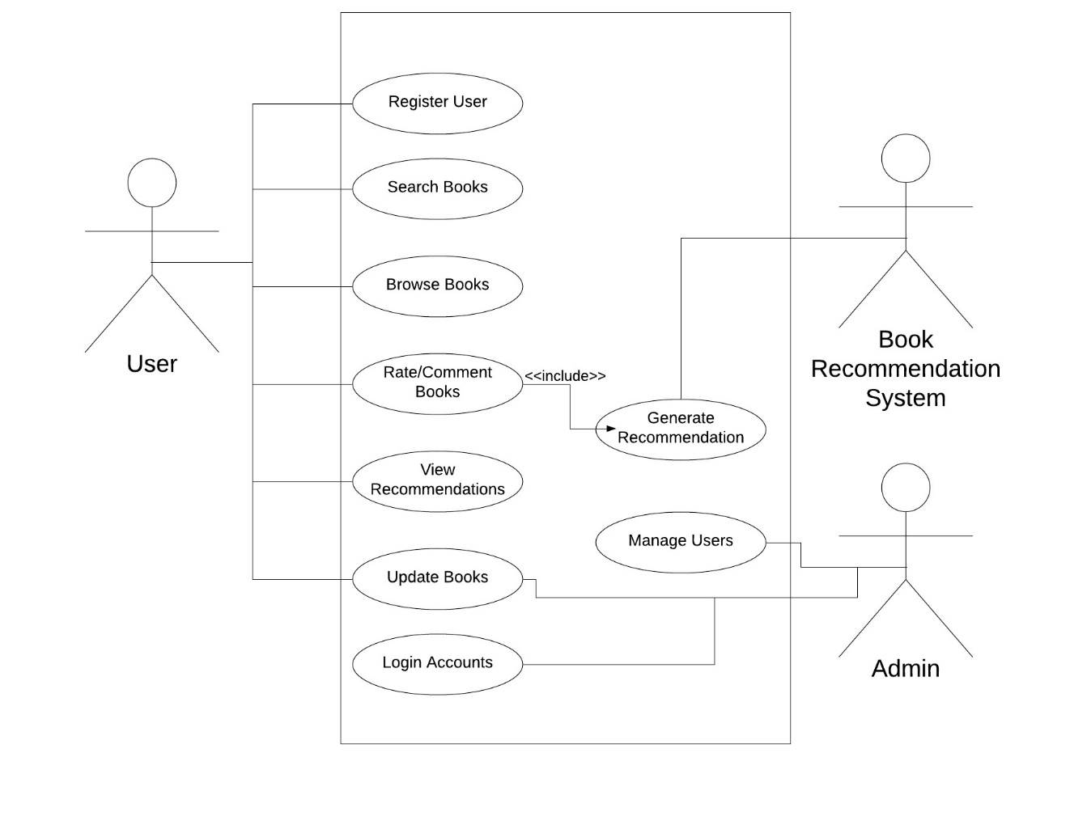

**Figure 1**: Use case Diagram for Books Recommendation System

The diagram above shows the use case diagram of the Book Recommendation System. Once the user is registered, gains access to the system, the user browse/search for books available in the database. The user reviews books which aids the system in generating recommendations which are later viewed by the user. The user can add or update books. The admin can manage books, user details in the system

## 3.2 Feasibility Study

### 3.2.1 Schedule

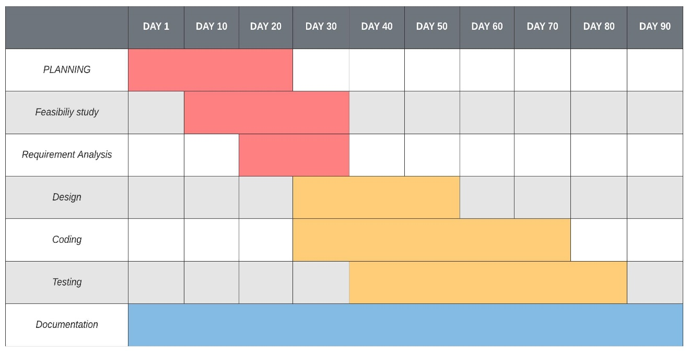

**Figure 2**: Gantt chart for Books Recommendation System

## 3.3 Structuring System Requirement

### 3.3.1 System Flowchart

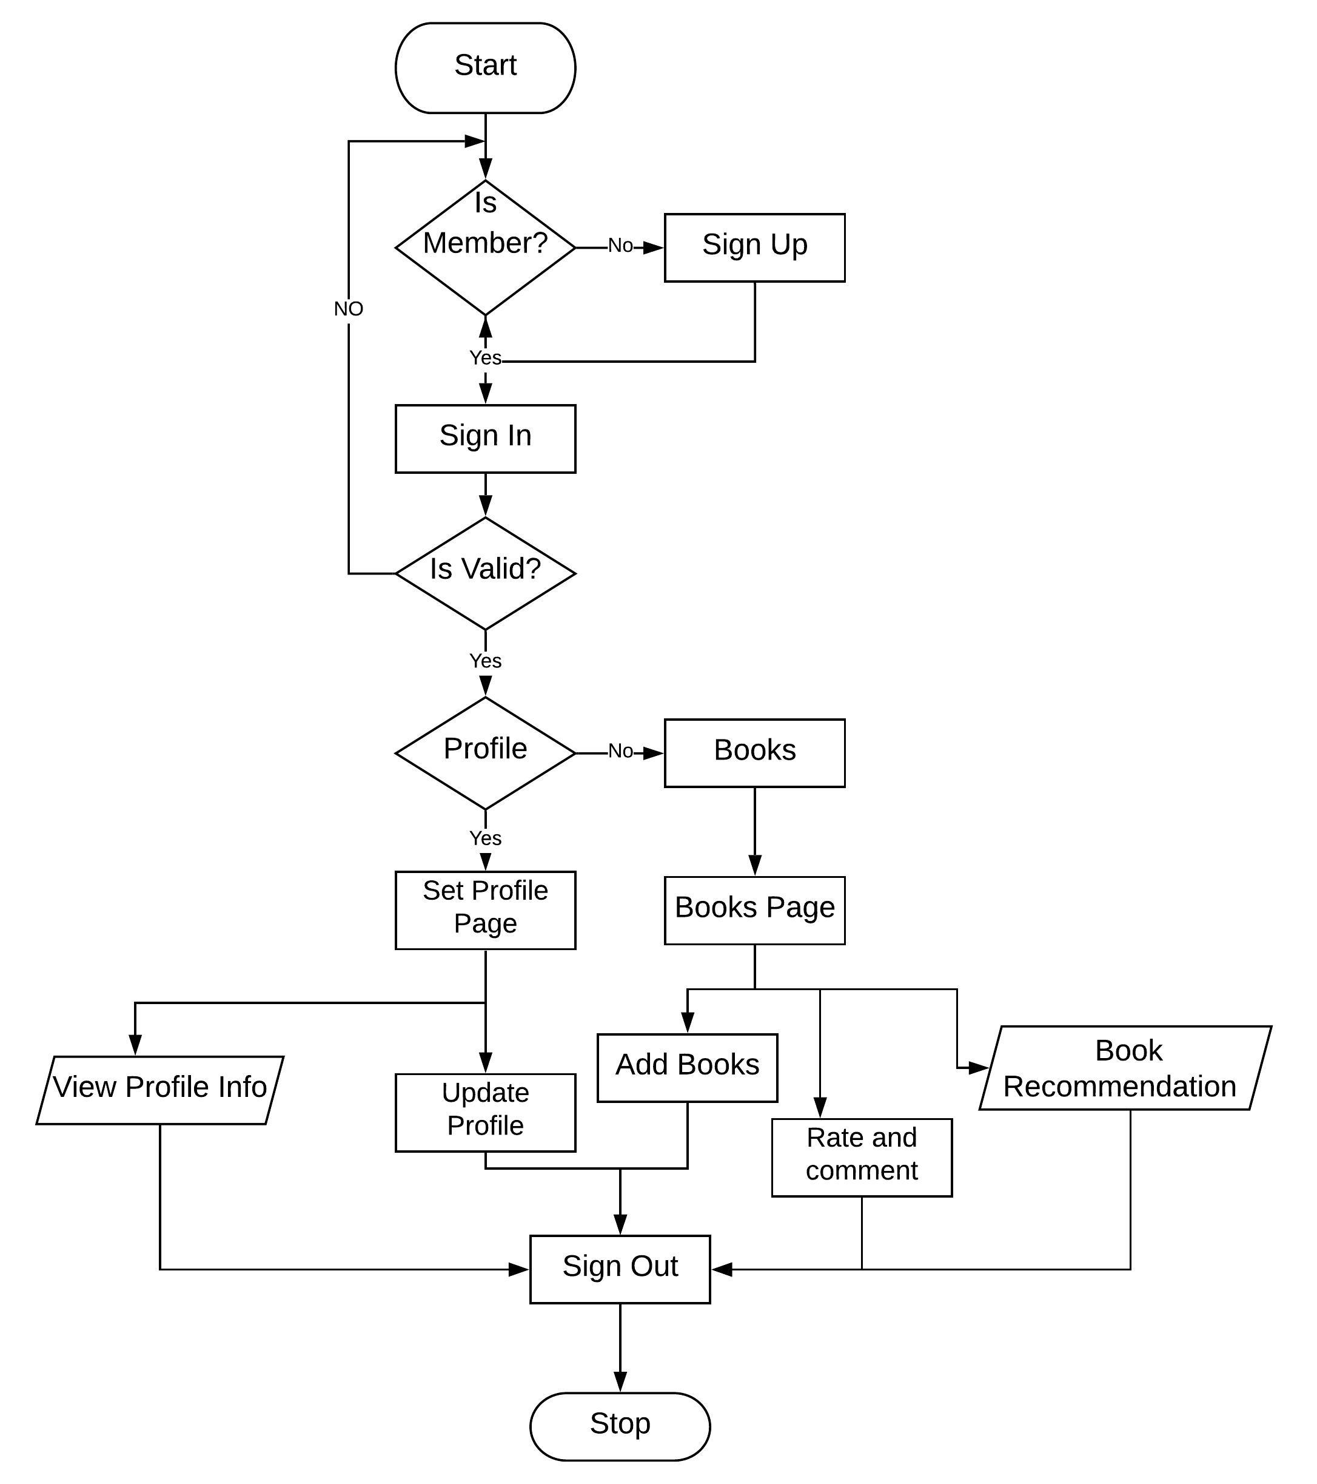

**Figure 3:** Flow chart for Book Recommendation System

The diagram in figure 3 shows the flow of the application. The user can register or login and update the user profile as well as visit the book page. In book page the user rates and comments the added book. The system provides recommendation as per the ratings of the book given by user.

The user adds book and provide ratings as well as comments. The website displays a list of books added in the database. A user can browse through them and look for the details of the books they are interested in. For simplicity, one can search through the book using the search bar provided at the top right corner of the website. In order to provide ratings and get recommendations, the user must register to the website by filling up the registration form. The user needs to fill some general details for the registration.

Once registered, the user can give ratings and comment on the books that he/she has watched. The system analyze the ratings it provides personalized recommendation for the user. For generating good personalized recommendations, the user needs to rate on ample amount of books.

### 3.3.2 Class Diagram

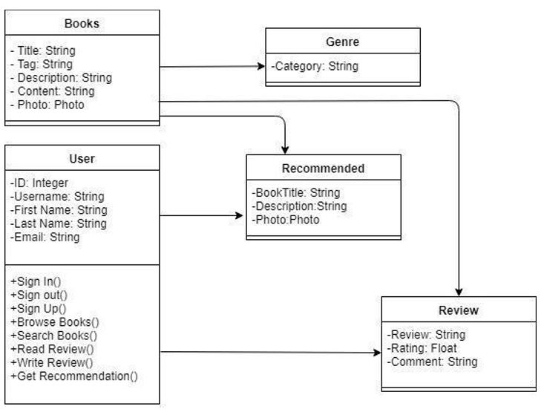

**Figure 4:** Class Diagram for Book Recommendation System

Figure 4 represents the class diagram for the application. It shows all the important classes along with their interaction. It shows the attributes and methods available for all the classes. A user class has attributes such as username, email, first name and last name. A user class has methods such as Sign In, Sign Up, Browse Books, Read Reviews, and Get Recommendations and so on.

# Chapter 4: System Design

## 4.1 Architectural Design

This system consists of major two parts, web application and recommendation system.

Basic system architecture is given below:

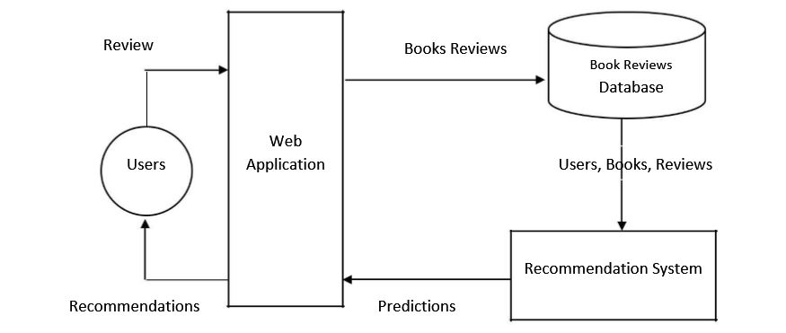

**Figure 5:** System Architecture for Book Recommendation System

Web application is for the end users for the reviews and viewing the recommendations whereas the recommendation system is the actual part where the algorithm work and logic is hidden.

## 4.2 Activity Diagram

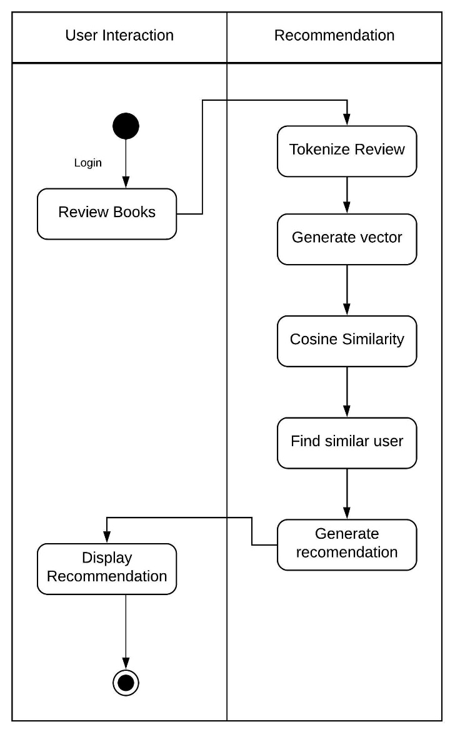

**Figure 6:** Activity Diagram for Book Recommendation System

Figure 6 represents the user interaction activity diagram. After the user reviews a book, the review is tokenized and converted into vectors. Cosine Similarity is implemented afterwards, which generates the degree of similarity between same users and generate recommendation from similar users and display the result to the user.

## 4.3 Sequence Diagram

### 4.3.1 Admin sequence diagram

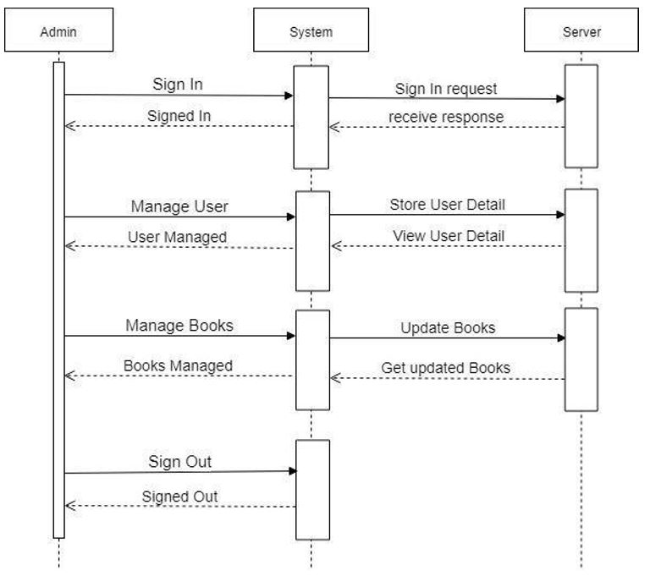

**Figure 7:** Admin Sequence Diagram for Book Recommendation System

In the figure 7, there are admin, system and Server. Admin can manipulate the data about the system and the user. They can monitor the activities of the user and the server. They can manage users and books Admin are the main person who have link with both user and the database. They can see the list of the entire user logged in the system as well as update the books in the system.

### 4.3.2 User Sequence Diagram

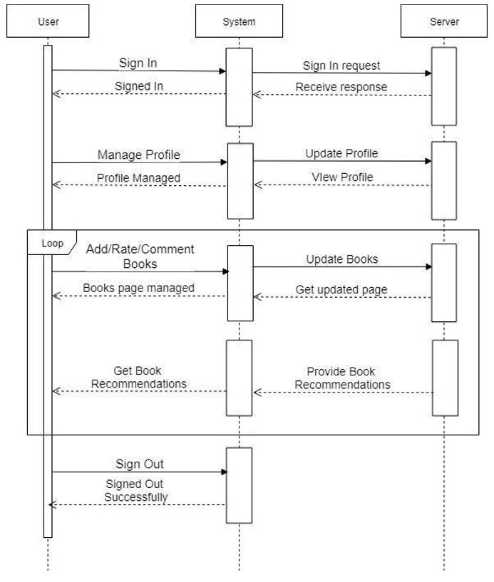

**Figure 8:** User Sequence Diagram for Book Recommendation System

In the user part, the major task is to rate and comment on the books that they have read. During this period user should go through the number of process. If the user is new then they should sign-up first and if the users already have an account then they should login their account. Then the user needs to rate the books they read. Comment is mandatory. On the basis of those reviews, the system provides the recommendation. Here the system acts as a mediator between the user and the database.

## 4.4 Algorithm

The user-based collaborative filtering algorithm relies on similarity. User’s preference similarity is used to have data analysis. Item resources the user might be of interest are recommended to the target user.

For a given user A, which likes the book x, and the user B, which might also like the same book.

For the user B,

If the user B’s preference of the book matches the preference of the book of user A.

Where other users in the database also matches the same preference which are neighbor to the user A.

Then recommend the matched preference to user B.

# Chapter 5 Expected Output

The output is expected to be a web based platform where the user can register themselves and can browse for books, review them and also can give various rating. They can also update the reviews and the system is expected to recommend books to the user based on their reviews and ratings history.

References

J.A.Horrigan Online shopping. http://www.pewinternet.org/2008/02/13/ onlineshopping,200

Beel and Joeran, Introducing Docear’s Research Paper Recommender System, In

Proceedings of the 13th ACM/IEEE-CS Joint Conference on Digital libraries, pp. 459–460,